**TODO Management System**

In this application there are few screens which are mentioned below:

1. Registration Page
2. Login Page
3. TODO Task list
4. Add new Task
5. Update existing task

The below frameworks have been used to develop this application:

1.Spring Boot

2.Spring Data JPA

3.Spring Security with UserDetailsService implementation.

4.In Memory H2 database

5.Embedded Tomcat Server

6.HTML for UI

We have used STS (Spring tool suite) is used as IDE.

**Spring Boot:**

Java Spring Framework (Spring Framework) is a popular, open source, enterprise-level framework for creating standalone, production-grade applications that run on the Java Virtual Machine (JVM). Java Spring Boot (Spring Boot) is a tool that makes developing web application and microservices with Spring Framework faster and easier.

**Spring Security:**

I utilized spring's user service implementation, so the data will come from the database rather than being hard coded in the code. After ensuring that the username exists in the database, we encode the password and construct the user information object using the builder design pattern.

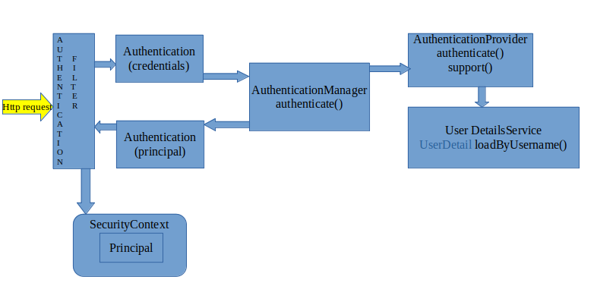

**Spring data JPA:** Used annotations to create and update the tables and also implemented one-to-many association for the User_Table and TODO table.

Application Screens:

1. **Registration Screen**

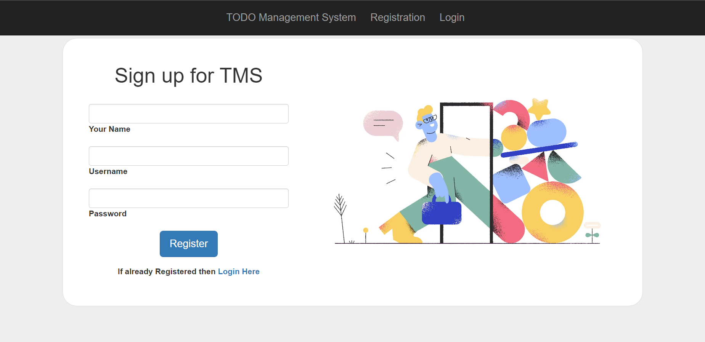

User can register from this portal, I have also added default user.

1. **Login Screen**

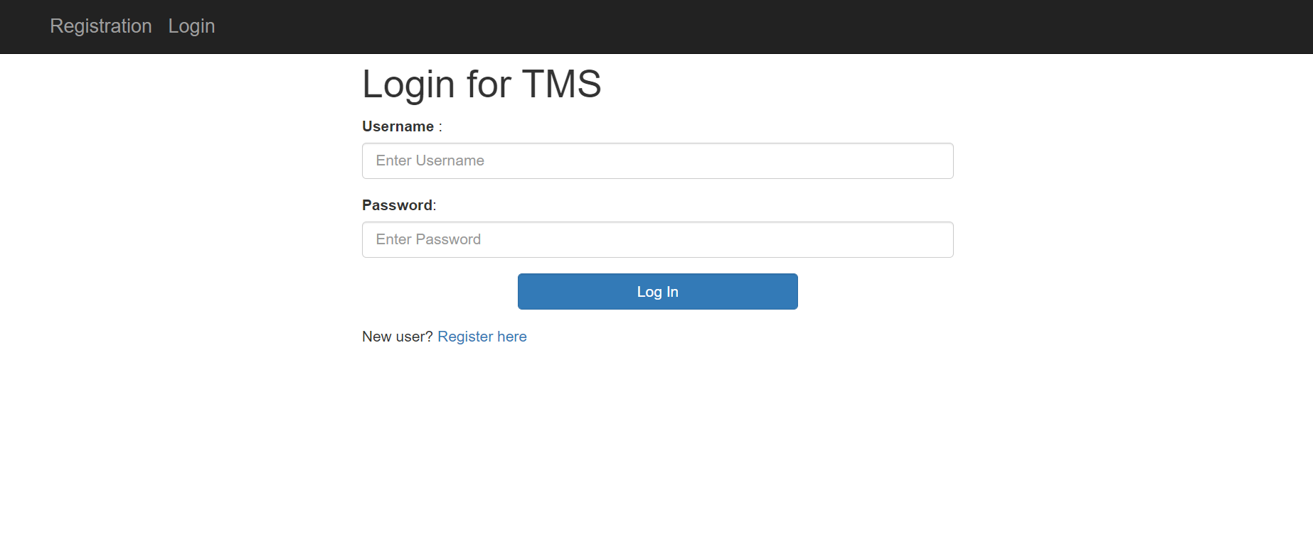

User can login from this page and will land to there dashboard.

1. **TODO Task Screen**

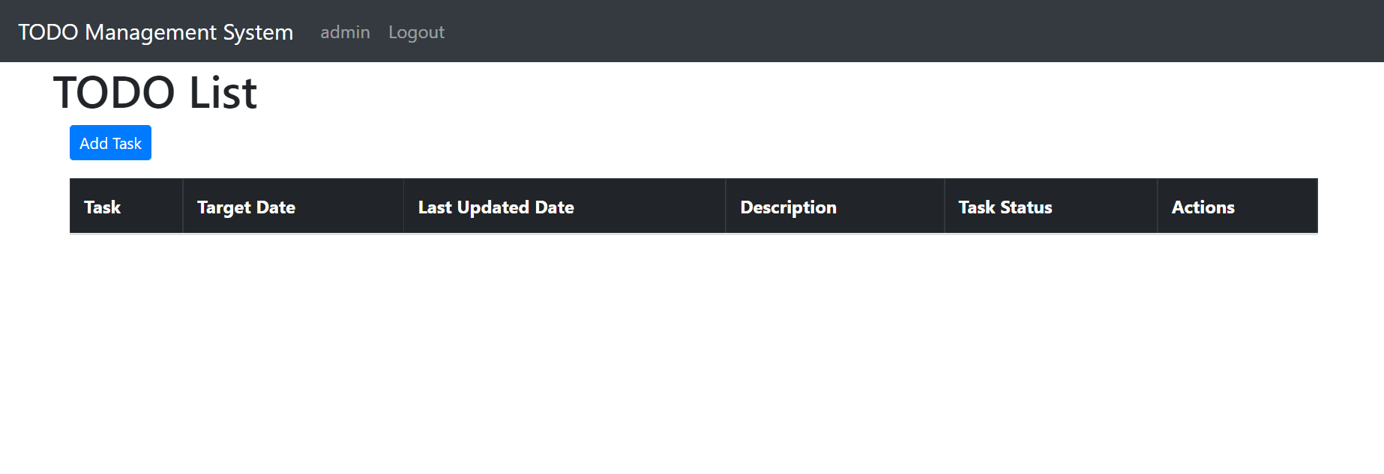

This the dashboard of the user where logout button is shown in the nav bar and the username is also shown in nav bar. User can add task by clicking on the Add task button.

1. **Add New Task Screen**

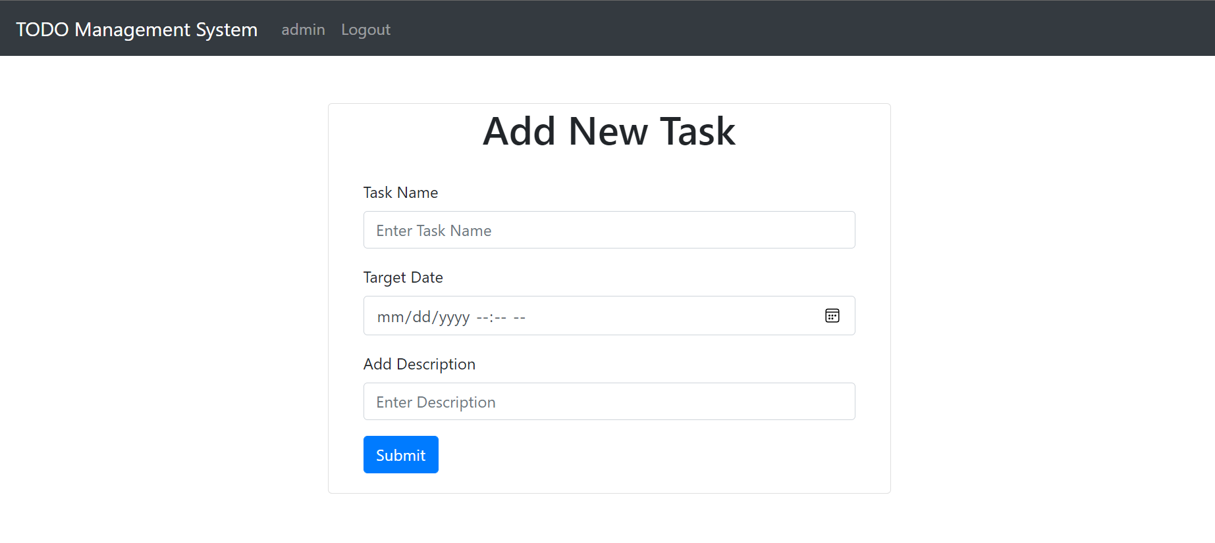

This is the add new task screen where user can add task name, target date with time and Task description.

1. **TODO Task screen**

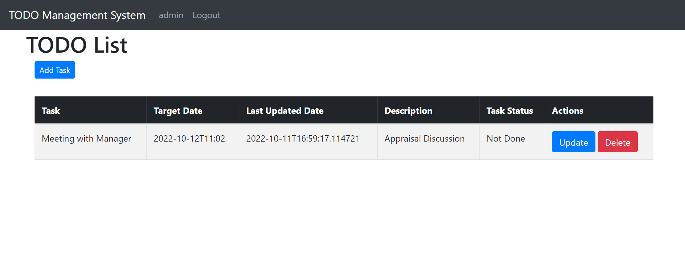

After adding new task, user will land to TODO Task page and the new added task will be shown and also the time at which the task updated is also shown. User can also update and delete the task by clicking on respective button.

1. **Update Task Screen**

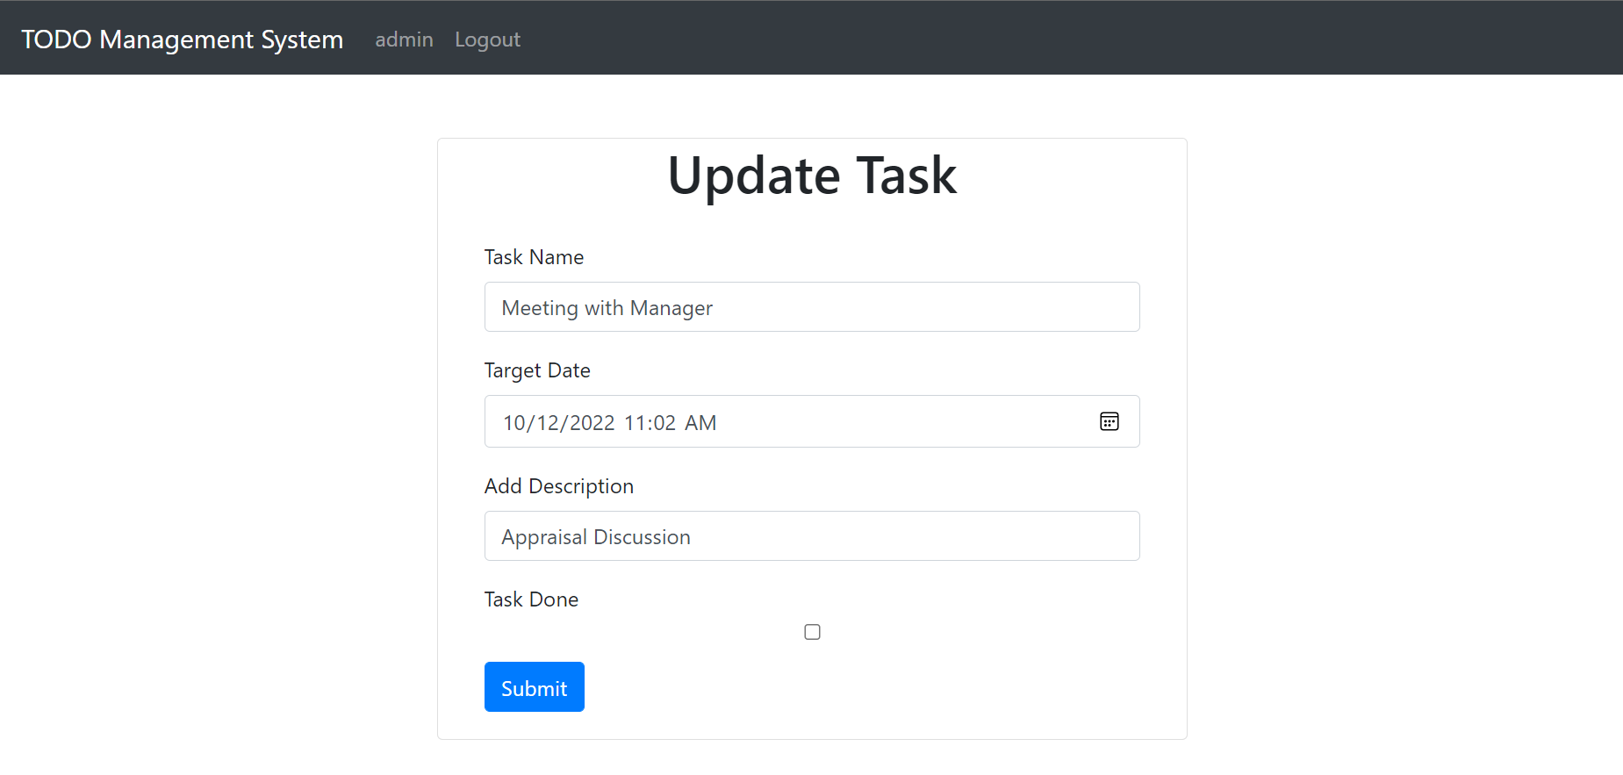

After clicking on update button user will redirect to update task page and user can update the task and he can also mark whether task is completed or not by submitting on checkbox.

1. **TODO Task screen after updating details**

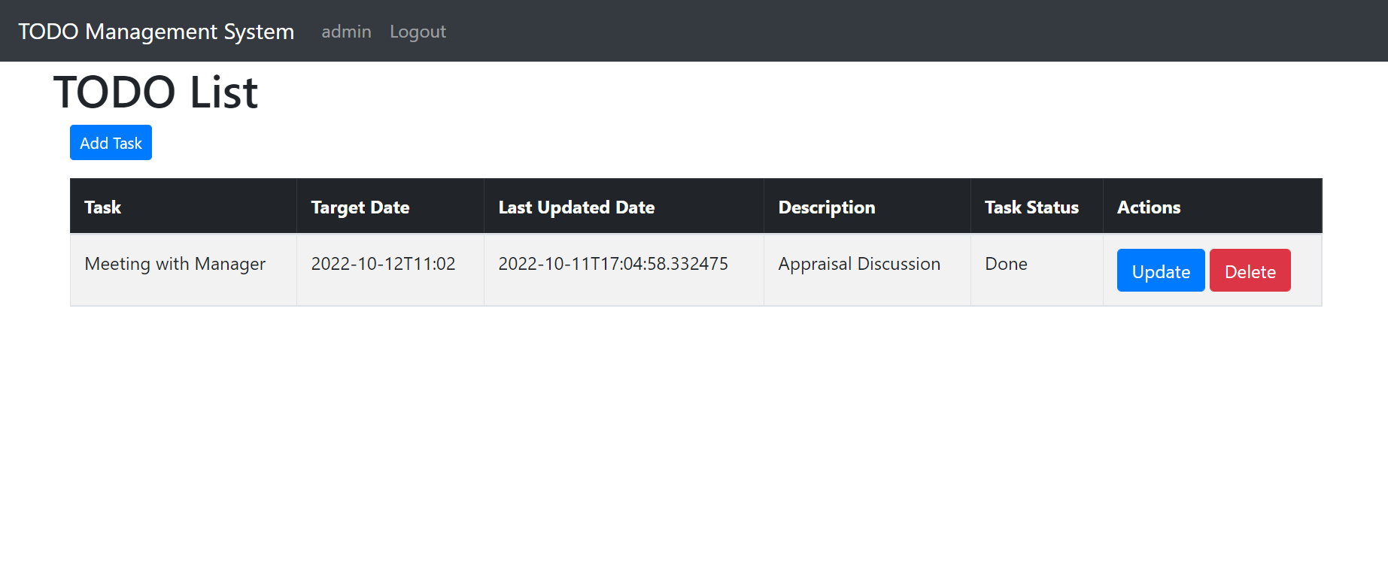

Here user can see the status which he marked while updating the task he has marked as task is completed hence it is showing that the task is done and user can also delete the task by clicking on the delete button.

1. **TODO task screen after deleting the task**

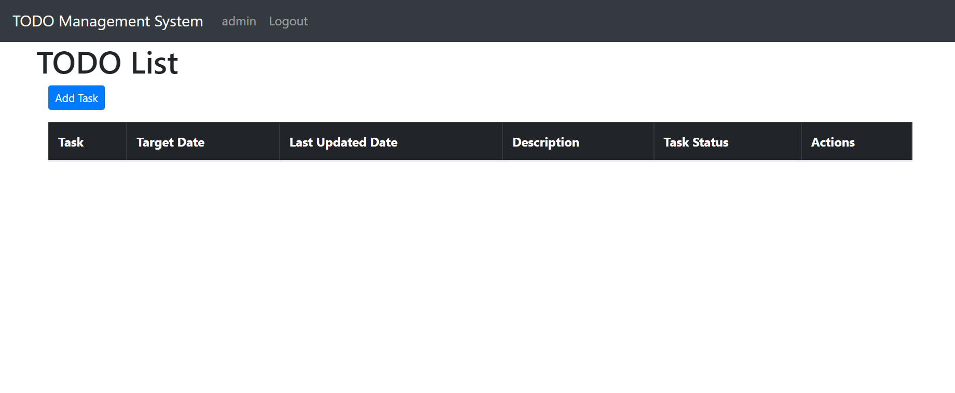

After user delete the task, he will land to TODO task screen and here we can see that the task is deleted.

**Steps to run the application:**

Provided the war file along with the source. Open command prompt where the jar file is available and use ‘java -jar TODOManagementSystem-0.0.1-SNAPSHOT.war’

Application will be running on the port number 8080.

Link: <http://localhost:8080/>

All the code files along with war file has been uploaded on Github and link is mentioned below:

<https://github.com/NickSarode/TODOManagementSystem>

Initial username and password is:

Username: admin

Password: password